Pattern Type -01
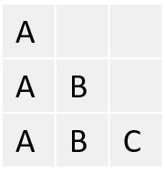
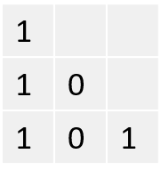
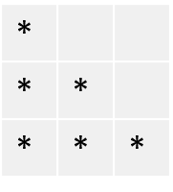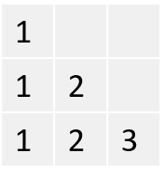

#include <stdio.h>
#include <stdlib.h>

int main()
{
int n,row,col ;
scanf("%d",&n);
for( row = 1 ; row<=n ; row++)
{
//space
for( col = 1 ; col<=n-row ; col++)
{
printf(" ");
}
for( col = 1 ; col<=row ; col++)
{
printf("%d ",col);
}
printf("\n");
}
for( row = n-1 ; row>=1 ; row--)
{
for( col = 1 ; col<=n-row ; col++)
{
printf(" ");
}
for( col = 1 ; col<=row ; col++)
{
printf("%d ",col);
}
printf("\n");
}
return 0;
}

